
The Superior University Gold Campus, Lahore
Faculty of Computer Science & Information Technology
Department of Software Engineering
Task 3:AI (Lab)
Student Name | Muhammad Awais Ur Rehman
Roll No | BSSEM-S25-026
Section | BSSE-4A
Subject | AI (Lab)
Submitted To | Sir, Rasikh Ali
Submission Date | November 6, 2026

1. Problem Description
A rescue robot has to find the exit in a building. It does not have any idea which way is best.Some routes are short some are long and some routes cost more to travel In this lab I used a small graph from the manual. It has nodes A to G. Start node is A and exit node is G.I implemented five uninformed search methods on this graph: BFS, DFS, DLS, IDDFS and UCS.The main point is that only finding a path is not enough. Two methods can find the same path but search in a different way. And the path with the fewest steps is not always the cheapest path.So for every method, I will show the path, the cost, and the order in which nodes were visited.
2. State-Space Formulation
Component | Definition used in this lab
Initial state | Robot is at node A
Actions / successors | Move along a corridor to a neighbour. Neighbours are taken in the order they are listed in the graph (left to right).
Goal test | Current node is G (the exit)
Path cost | Task 1 and 2: Number of steps, each step = 1. Task 3: Sum of corridor costs
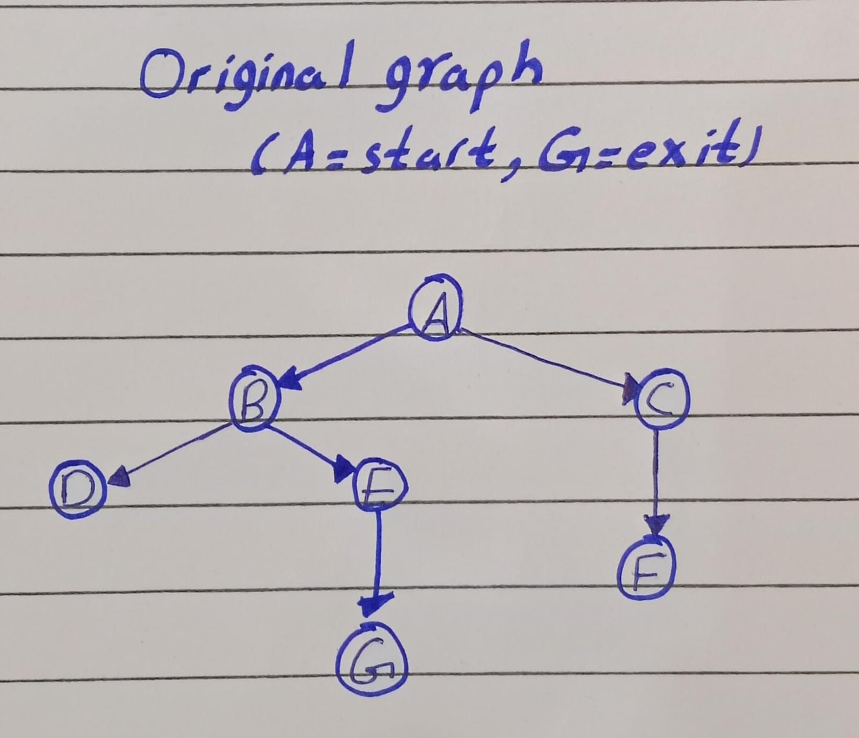
3. Assumptions
Successor order is the tie-breaking order, so the left neighbour is always tried first.
Depth is counted by edges, so A has depth 0 and G has depth 3.
When I count processed nodes, the goal node is also included. Nodes that are already processed are skipped and not counted again.
For Task 3, I used the extra corridor from Section 3.7. All original corridors are kept and C -> G is added as an extra corridor. This is only for the weighted experiment, not for the original graph.
The weight table was not in my copy of the manual, so I chose the weights myself to match Section 3.7. A -> C -> G costs 12 and A -> B -> E -> G costs 3. All weights are positive.
UCS checks the goal when a node is removed from the priority queue, not when it is added.
4.Task 1: BFS and DFS Traces
Start is A, goal is G, on the original A-G graph. I followed the manual rule: list each node that is removed from the queue or stack and processed, including the goal, skip processed duplicates, and stop when G is processed. The traces below are the actual output of lab3_bfs_dfs.py.
BFS trace (queue)
Step | Processed | Queue after step | Path so far
1 | A | [B, C] | A
2 | B | [C, D, E] | A -> B
3 | C | [D, E, F] | A -> C
4 | D | [E, F] | A -> B -> D
5 | E | [F, G] | A -> B -> E
6 | F | [G] | A -> C -> F
7 | G | [ ] | A -> B -> E -> G (goal)

DFS trace (stack)
Step | Processed | Stack after step | Path so far
1 | A | [C, B] | A
2 | B | [C, E, D] | A -> B
3 | D | [C, E] | A -> B -> D
4 | E | [C, G] | A -> B -> E
5 | G | [C] | A -> B -> E -> G (goal)

Verification and interpretation
I ran the manual BFS and DFS code (kept in my file as bfs_manual() and dfs_manual()). Both returned ['A', 'B', 'E', 'G'], which is the same path as my traces. The visit orders also match the manual (BFS: A, B, C, D, E, F, G and DFS: A, B, D, E, G).
Both methods give the same path here because there is only one route from A to G. But they searched in a different way. BFS went level by level and processed 7 nodes, including C and F which are not on the answer path. DFS went deep into B first, tried D (a dead end), then E and G, and finished after 5 nodes without touching C or F. In the stack trace we can see that C stays at the bottom the whole time. It was added at step 1 but was never needed.
The reversed insertion is what makes DFS follow the first listed neighbour. After A is processed, the stack is [C, B] with B on top, so B is removed next and not C.

5. Task 2: DLS and IDDFS
Prediction before codingThe exit G is at depth 3 (A -> B -> E -> G). So I predicted that limits 1 and 2 cannot reach G and should return Cutoff, because deeper nodes still exist. Limits 3 and 4 should return Found.
DLS results
Limit | Status | Path | Nodes processed
1 | CUTOFF | None | A, B, C (3)
2 | CUTOFF | None | A, B, D, E, C, F (6)
3 | FOUND | A -> B -> E -> G | A, B, D, E, G (5)
4 | FOUND | A -> B -> E -> G | A, B, D, E, G (5)

IDDFS results
Max depth | Status | Limits attempted | Nodes per limit | Total processed
1 | CUTOFF | 0, 1 | 1, 3 | 4
2 | CUTOFF | 0, 1, 2 | 1, 3, 6 | 10
3 | FOUND | 0, 1, 2, 3 | 1, 3, 6, 5 | 15
4 | FOUND | 0, 1, 2, 3 | 1, 3, 6, 5 | 15

Repeated work and why limits below 3 fail
IDDFS processed 15 nodes in total when max depth was 3, but a single DLS with limit 3 needs only 5 nodes. The extra work is the repeated search of the shallow levels: node A is processed once for every limit (4 times in total). This is the price of IDDFS. In return, it needs only DFS-like memory and still finds the shallowest goal. In a tree with a large branching factor, most nodes are at the bottom level, so the repeated shallow work is a small part of the total.
Limits 1 and 2 fail because the only route to G has 3 edges. At limit 2, the search reaches E at depth 2, but E is not allowed to expand further, even though G is its successor. That is why the status is CUTOFF and not FAILURE: something deeper still exists. A limit of 2 only tells us that G was not found within 2 steps. It does not prove that G is unreachable.
When I tested an unreachable goal Z, DLS gave CUTOFF at limit 2 but FAILURE at limit 3, because at limit 3 every branch ends completely. This shows why the two statuses must be kept separate.
6. Task 3: UCS on the Weighted Graph
Weighted graph
Edge | Weight | Note
A -> B | 1 | original corridor
A -> C | 5 | original corridor
B -> D | 2 | original corridor
B -> E | 1 | original corridor
C -> F | 2 | original corridor
E -> G | 1 | original corridor
C -> G | 7 | ADDED corridor (Section 3.7 extension, not in the original trace graph)

UCS processing order
Step | Processed | Cost so far | Frontier after expansion (node:cost)
1 | A | 0 | B:1, C:5
2 | B | 1 | E:2, D:3, C:5
3 | E | 2 | D:3, G:3, C:5
4 | D | 3 | G:3, C:5 (D has no successors)
5 | G | 3 | C:5 (goal processed, stop)

7.Complexity Comparison
Strategy | Complete? | Optimal? | Key resource | Behaviour
BFS | Yes (finite branching) | Yes, equal step cost | High memory (wide frontier) | Visited 7 nodes here
DFS | Not always | No | Low memory | Visited 5 nodes here
DLS | If limit sufficient | No | Depth bounded | Limits below 3 give CUTOFF
IDDFS | Yes | Yes, equal step cost | Repeated shallow work | 15 nodes total vs 5 for DLS 3
UCS | Yes, positive costs | Yes | Priority queue by cost | Found cost 3, not cost 12

8. Testing, Edge Cases and Failure Analysis
Edge-case tests
Test | Input | Observed result
Start equals goal | start A, goal A | BFS, DFS, DLS limit 0, IDDFS: path [A]; UCS: path [A], cost 0
Unreachable goal | BFS/DFS/UCS: start C, goal D (or E in the weighted graph) | All return None (no path)
Unreachable goal with depth limits | DLS goal Z on the A-G graph | Limit 2: CUTOFF. Limit 3: FAILURE. IDDFS stops with FAILURE at limit 3.
Graph with a cycle | A->B->C->A and C->D, goal D | BFS, DFS and DLS (limit 5) all return A, B, C, D. No infinite loop.
Cycle, unreachable goal | same graph, goal Z | DLS / IDDFS give FAILURE and the others give None
Weighted cycle | A<->B (cost 1 each), B->C (2) | UCS returns A, B, C with cost 3

Failure case: negative edge in UCS
Part | Description
Input | Edges A -> B = 2, A -> C = 5, C -> B = -4. Start A, goal B
Observed behavior | UCS returned A -> B with cost 2. The processing order was A (0), B (2)
Correct answer | A -> C -> B costs 5 + (-4) = 1, which is cheaper than what UCS returned
Likely cause | UCS assumes that cost never decreases along a path. Once B is removed from the heap with cost 2, it is treated as final, so the cheaper route through C is never checked
Proposed improvement | Check the input and reject negative weights for UCS. If negative edges are really needed, use Bellman-Ford (with negative-cycle detection) or another method that can handle them

Second edge case: global visited set in DLS
On a small diamond graph (S -> X, S -> Y, X -> Y, Y -> G) with limit 2, DLS with a path-local check correctly finds S -> Y -> G. A version with a global visited set returned CUTOFF. It reached Y first through X (depth 2, no room to continue) and then refused to visit Y again from S at depth 1. This is the reason I did not use a global visited set in DLS and IDDFS.
9. Limitations
The graph has only 7 nodes, so time and memory differences are only seen through node counts and not through real measurements
The Task 3 weights were chosen by me to match Section 3.7. Different weights could change the processing order
All counts depend on the successor order. A different order would change the visit orders (but not the optimal cost of UCS)
Recursive DLS can hit Python's recursion limit on very deep graphs
UCS here needs non-negative weights and does not handle negative edges

